Knowledge is knowing a tomato is a fruit. Wisdom is not putting it in a fruit salad. Dr. Laura

IACPR Newsletter
[Date]

Welcome to our first re-invented newsletter. At the Spring conference, our board of directors had their annual face to face meeting. During this meeting, our newly appointed President Elect, Peg King, who has served as the Secretary for many years, suggested we bring back our newsletter. We all agreed that it was a fantastic idea. So, we are going to put out a newsletter after the Spring conference and our fall regional meetings. The objectives of these newsletters are to; keep you informed about recent topics, summarize our spring conference, introduce you to members of the board and show opportunities to help with your Iowa Association.
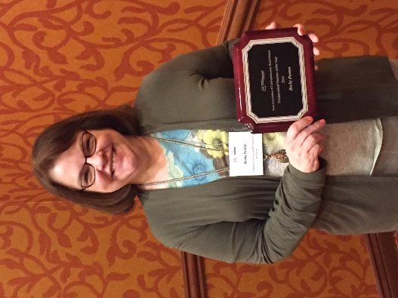
To start, this year’s conference was held in remembrance of Becky Paxton. Becky served the Iowa Association of Cardiopulmonary Rehab, as treasurer, since 2006. She was integral in developing the new website. She was a fun happy person who was always willing to help. Two of her coworkers were present at the conference and asked us to perform random acts of kindness in her honor. She will be greatly missed.
We had several fantastic guest speakers. One highlight from this year’s conference was provided by Kim Eppen. She gave an amazing presentation on exercise prescription and considerations for exercise testing. Kim also left us with some handy handouts to calculate MET levels with 6MWT. The organization also discussed new regulations for Cardiac and Pulmonary rehab. The ITP (Individual Treatment Plan) is to be signed before the patient can be charged for exercise. We listened to good dialogue regarding ideas on how to implement these new changes. Pulmonary rehab also has its own set of changes with the ITP. Refer to www.iacpr.net for more information. Another added benefit of membership to IACPR.
Made in Office 2007 for office2007.com
The associations current President Deb Anderson has served on the IACPR board for 10 years. She has worked in cardiopulmonary rehab for 22 years. In July, she will step to the position of Past President and Jolene Stackis will serve as President. Deb currently works at CHI Health Mercy in Corning Iowa. Deb has two grown children and enjoys spending time with them. Her daughter and son-in-law and their 3 dogs live across the state and her son lives closer to home in southwest Iowa. She keeps busy with work and church activities and recently took up learning the violin. Maybe at next year’s conference Deb will play us a tune on her violin.
The IACPR distinguished member of the year award was conferred to Claire Shannon. She was nominated by her fellow friends and IACPR members. Some quotes stated about Claire were, “Claire started a standardization committee in 2009”, “Even though she moved out of state she continues to be active in Iowa” and “Whether it is her patiently listening to concern someone has, volunteering to teach yoga at our conferences with no expectation of reimbursement, remaining a leader on the board despite taking a new position in Nebraska and at one time not even in the field of rehab, or the many other things that are too numerous to mention!” We thank Claire for her continued dedication to the organization.
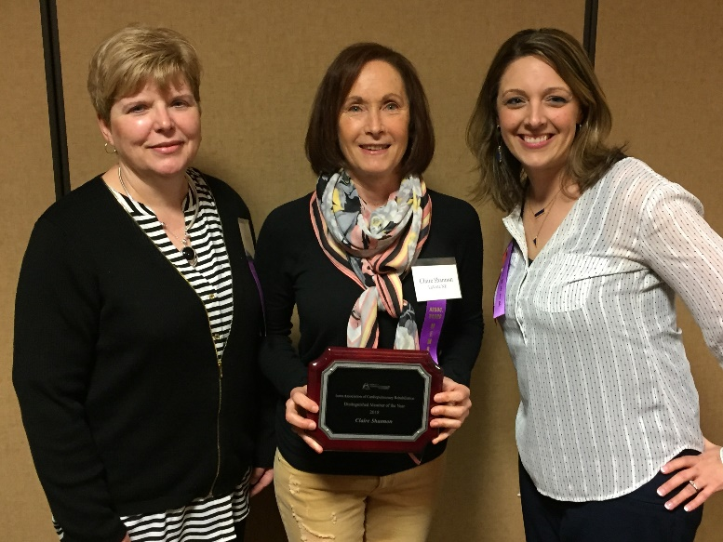
Please reach out see what you can do to help. We are always looking for volunteers. Without volunteers we would not have this successful group.
IACPR Committee Members 2017-2018
Made in Office 2007 for office2007.com
President: Deb Anderson
Past President: Claire Shannon
President Elect: Jolene Stackis
Secretary: Peg King
Treasurer: Deb Anderson
Directors:
Aleisha Bloker
Karie Martin
Denise Promes
Brandy Tripp
Amy Alton-Stonebrook

COMMITTEE LEADERS and Members
Budget and Finance: Deb Anderson (Treasurer)
Denise Promes (Director)
Communication: Leah Lenz (Chairperson)
Karie Martin (Director) and Peg King (Director)
Education: Brandy Tripp, Aleisha Bloker (Directors)
Mary Shaughnessy-Swisher, Jennifer England, Diane Callahan, Laura Mackaman, Krystle Primus, Marcia Hosier, Patricia Jensen
Membership:
Jolene Stackis, Amy Alton-Stonebrook (Director)
New Chair available
Reimbursement/Legislative:
Janie Knipper (Chairperson)
Susan Flack
Claire Shannon and Deb Anderson (Director)

REMEMBER, renewal of membership will be due in June. The membership rates are low, and you get several benefits, including discounted rates to the Spring Conference and updated information on reimbursement and changes in procedures.

