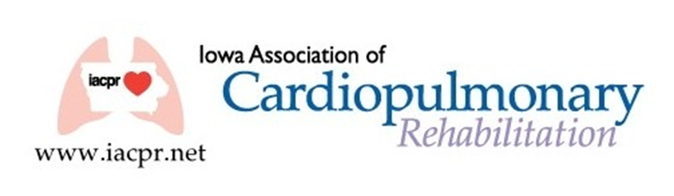

**IACPR Committee Members 2022-2023**

**President:** Eric Larson

**Past President**: Peg King

**President Elect**: Brandy Tripp

**Secretary**: Julie Waltenberger

**Treasurer:** Deb Anderson

**Directors**:

Julie Waltenberger

Lindsey DeJong

Sharon Mays

Julie Wiebold

**COMMITTEE LEADERS**

**and**

**Members**

**Budget and Finance**:

Deb Anderson (Treasurer)

Eric Larson (Director)

**Communication**:

Leah Lenz (Chairperson)

Peg King (Director)

Julie Waltenberger (Secretary)

**Education**

Brandy Tripp (Chairperson)

Lindsey DeJong (Director)

Diane Callahan

Krystle Primus

Denise Promes

Eric Larson

Erika Leonard

**Membership**:

Michelle Litterer (Chairperson)

Julie Wiebold (Director)

**Reimbursement/Legislative**:

Susan Flack (Chairperson)

https://iacpr.net/resources/Pictures/Peg%20King.jpg

# Fall 2022 Issue

# President’s Message

The leaves are changing, and the air is getting brisk…another beautiful fall in Iowa. As the weather changes, we within the Cardiac and Pulmonary Rehabilitation world are seeing changes as well…many hospitals are lifting mask mandates, and volumes across the state seem to be back to normal, in some cases even higher. With these changes, come questions and concerns, we at IACPR want to make sure all our programs across the state are fully versed on the guidelines in our ever-changing environment. IACPR’s website offers a multitude of resources for members as well as a Board of Directors with multiple years of experience. Please feel free to check out these resources.

In the next few months, the Board will be updating the strategic plan and working to see how we can help our members continue to grow and succeed in the field of cardiopulmonary rehab. One exciting initiative is planning and organizing a ‘Grass Roots’ program. This is being designed to help those individuals new to cardiopulmonary rehab or those that just need a refresher. More information to come.

Exciting news as well, we are officially planning a ‘Live’ annual conference this year. The Education Committee is working hard to bring in a fantastic group of speakers for 2 days of fun and learning.

Sincerely,

Eric Larson

IACPR President

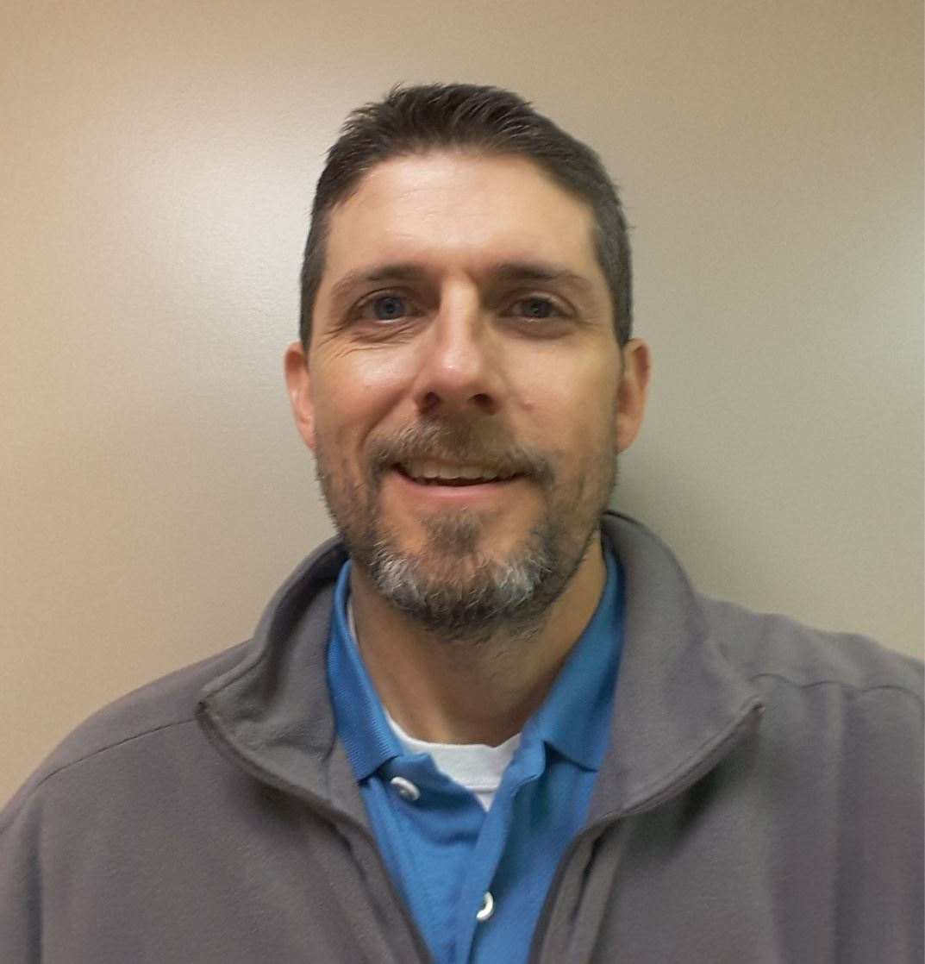



**Congratulations to Susan Flack of UnityPoint, she was presented as a fellow of the AACVPR.**

**CONGRATS SUSAN!!!**

They will receive a free registration to the IACPR Conference.

IACPR conference in 2021.

**Distinguished Member of the Year**

2021 – Debbie Anderson

2022 – Denise Promes

**Scholarship winners 2020**

Newbie:

2021 - Julie Wiebold

Seasoned:

2021 - Vicki Paolovec

**AACVPR Membership**

2021 – Teresa Hardy

The IACPR needs member participation to survive. I am therefore putting a call out to all members of IACPR that may be interested or would like to inquire about serving on the Board or the Education Committee of IACPR. The Education Committee establishes content, plans, and carries out the Spring Conference and any other educational programs offered by IACPR. Serving on statewide committees or the Board of Directors for IACPR helps develop leadership skills, provides networking opportunities, and volunteering in a professional association looks great on a resume. If you have possibly thought of helping out or have general questions regarding serving, please feel free to reach out to me at [eric.larson503@commonspirit.org](mailto:eric.larson503@commonspirit.org).

**Election of Board of Directors**

Thank you to all who voted and for Leah sending out those email blasts to get everyone to vote! The following candidates were elected to the board

Lindsey DeJong

President - Elect: Brandy Tripp

Appointed Secretary: Julie Waltenberger

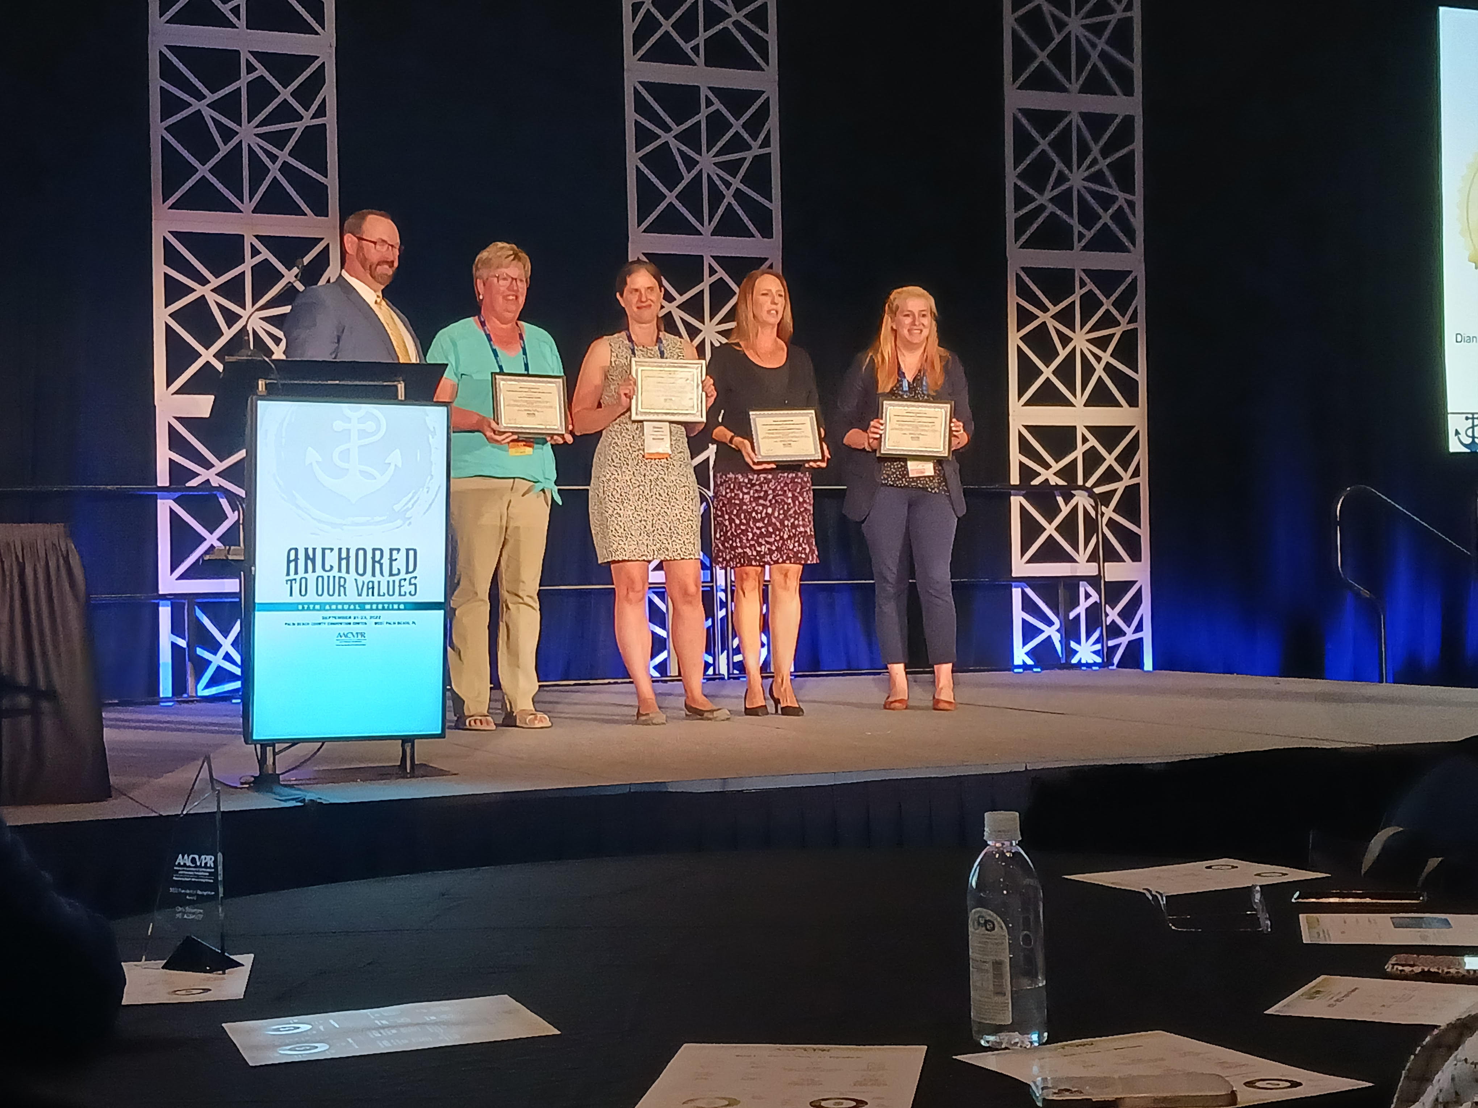

Peg King, Jolene Stackis & Carrie Adams